## Shipping Documentation

All shipments of biological materials and dangerous goods must be accompanied by appropriate shipping documentation. The types of documents that are required depend on the nature and destination of the shipment. The shipper is responsible for providing accurate information and documentation applicable to the shipment of goods.

**Types:**

* Air Waybill
* Contains contact information and basic shipment identification information.
* Required for every shipment
* Available from couriers (e.g. FedEx)
* Commercial Invoice
* Contains specific language for Customs.
* Required for international shipments
* Available from couriers and online
* Shipper’s Declaration of Dangerous Goods
* Contains detailed shipment information and emergency contact information.
* Required for chemicals (except small/excepted quantity shipments) and Category A Infectious materials.
* Available from couriers and online.
* Must be in English, typed, and printed in color.
* FedEx requires that Declaration Forms are prepared using compliance check software (contact Environmental Health & Safety Office for more information).
* 3 color copies must be included with the package
* 1 copy must be kept by the shipper for at least 375 days.

**Example: Airway Bills**

* Domestic shipment of a dangerous good requiring a Shippers Declaration (e.g. Category A shipment)



* Domestic shipment of a dangerous good not requiring a Shippers Declaration (e.g. Dry Ice)



* International Shipment of a dangerous good



**Example: Commercial Invoice**

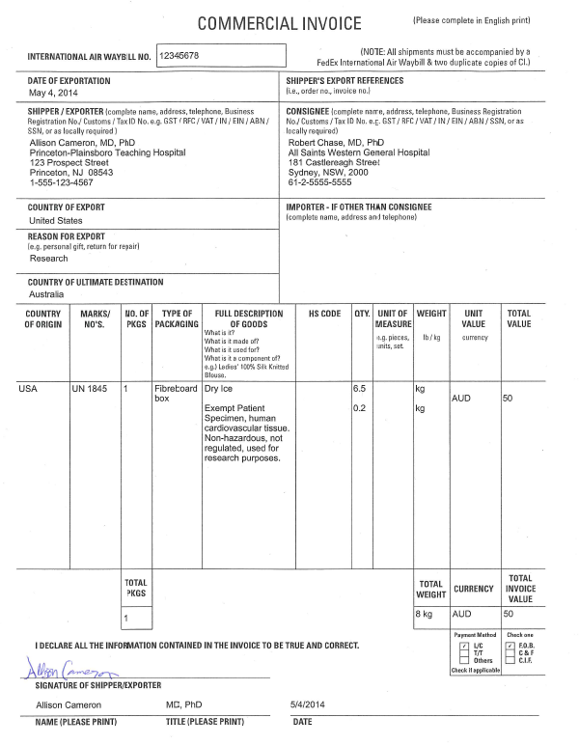

**Example: Shippers Declaration**

