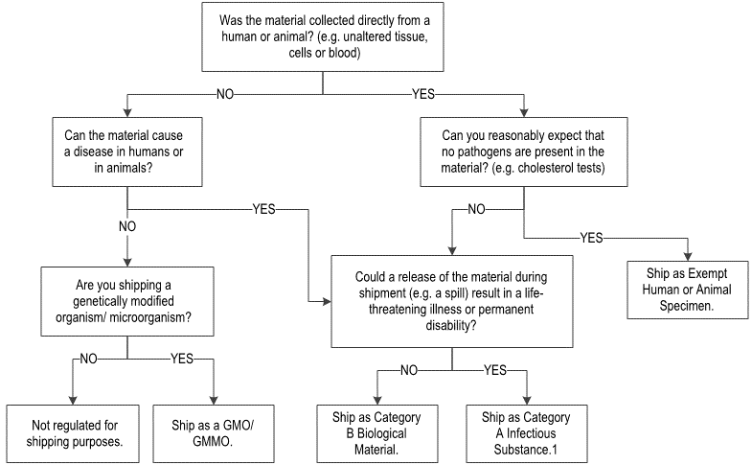

1. Please see page 25 for an indicative list of agents that must be shipped as Category A.