How-to Guide: Shipping Category B Infectious Substances
What You Need:
For help classifying your biological substance, refer to the flowchart on page 21.
- 4L or less of a Category B Biological Substance
- Triple-packaging materials (does not need to be UNPOP-certified)
- Absorbent materials
- Itemized Content List
- UN ID 3373 label and Proper Shipping Name label
- Air Waybill
- A certified shipper to assemble package and fill out paperwork

Instructions:
- Place the Category B Biological Substance in a sealed, water-tight primary container. Multiple primary containers can be shipped in one package.
- Wrap multiple containers to prevent breakage.
- Place absorbent materials between primary container(s) and secondary container. Absorbent materials must be able to absorb the entire liquid contents of the shipment.
- Seal the secondary container with the absorbent materials and primary container(s) inside.
- Place itemized contents list between the secondary and outer packaging
- Place the secondary container securely within the outer container.
- Seal the outside container with packing tape or provided seal.
- Label the outside container with the sender/recipient information, emergency contact information and UN 3373, Biological Substance, Category B.
- Complete an air waybill for the shipment. Be sure to indicate on the waybill that a dangerous good is being shipped and that a declaration form is not required.
- Keep the Sender’s Copies of the waybill for at least 375 days. Attach the courier and recipient copies to the package.

Packaging, Paperwork, and Labeling Summary:

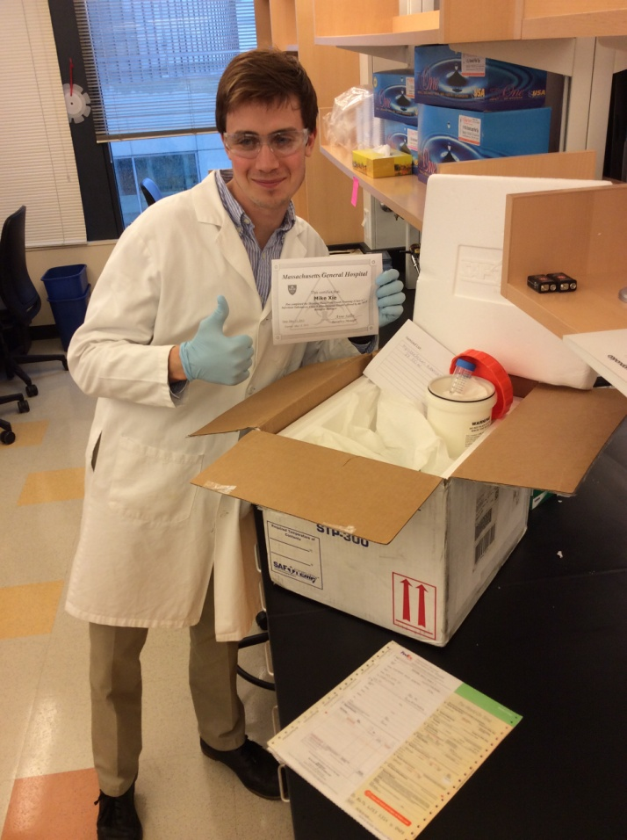
Certified Shipper- trained within past 2 years
Primary Containers- sealed, watertight
Absorbent- separating containers and adequate to absorb all liquid (2 x 50 ml)
Secondary Container- sealed, watertight
Itemized Content List
Dry Ice and Cushioning Paper- filled to prevent movement when dry ice evaporates (if applicable)
Foam Shipper- lid unsealed to allow venting (if applicable)
Outside container- seal with packing tape
Airway Bill
Labels- see picture below

